**My Profile:**

On clicking on User profile, you will get ‘My profile’. You can update your personal, parents & Educational detail from here.

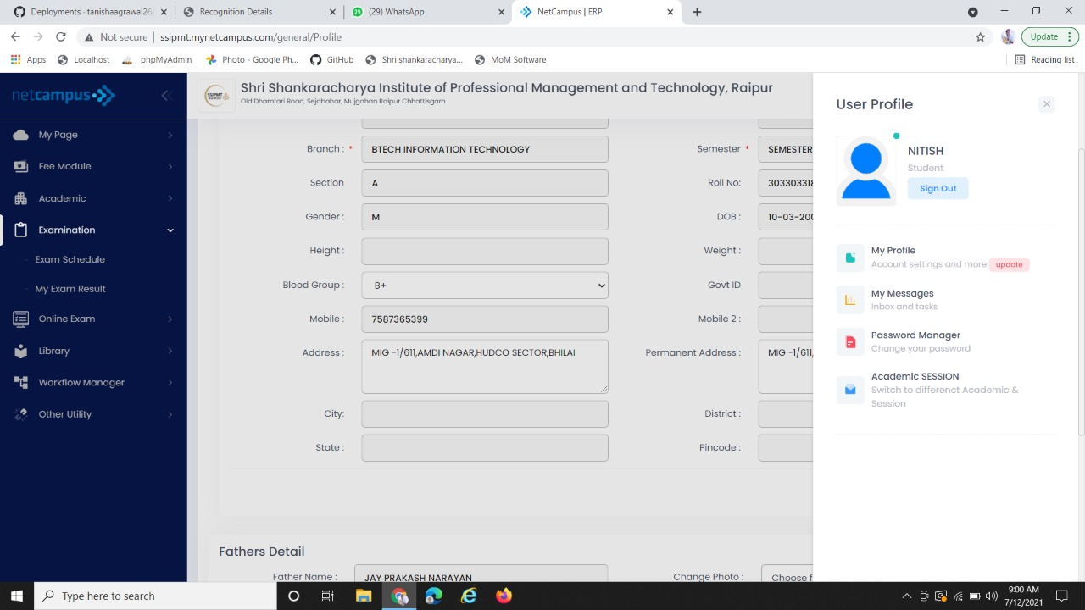

You can sign out from here

You can edit your personal detail from here. After editing your profile details click on ‘Update’ button.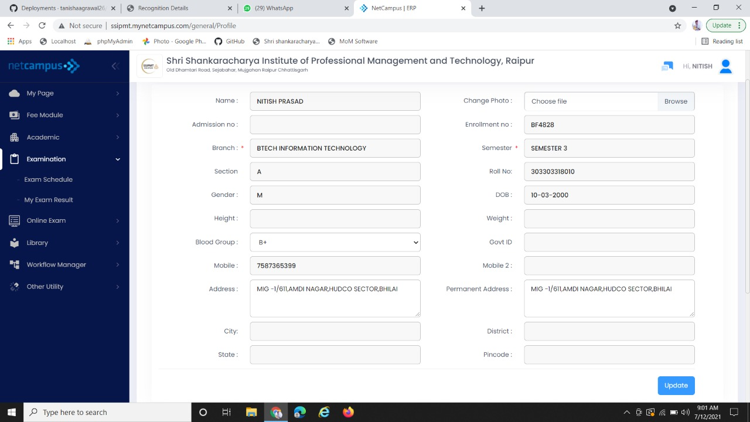

You can change your picture from here

After updating the personal details click on update button.

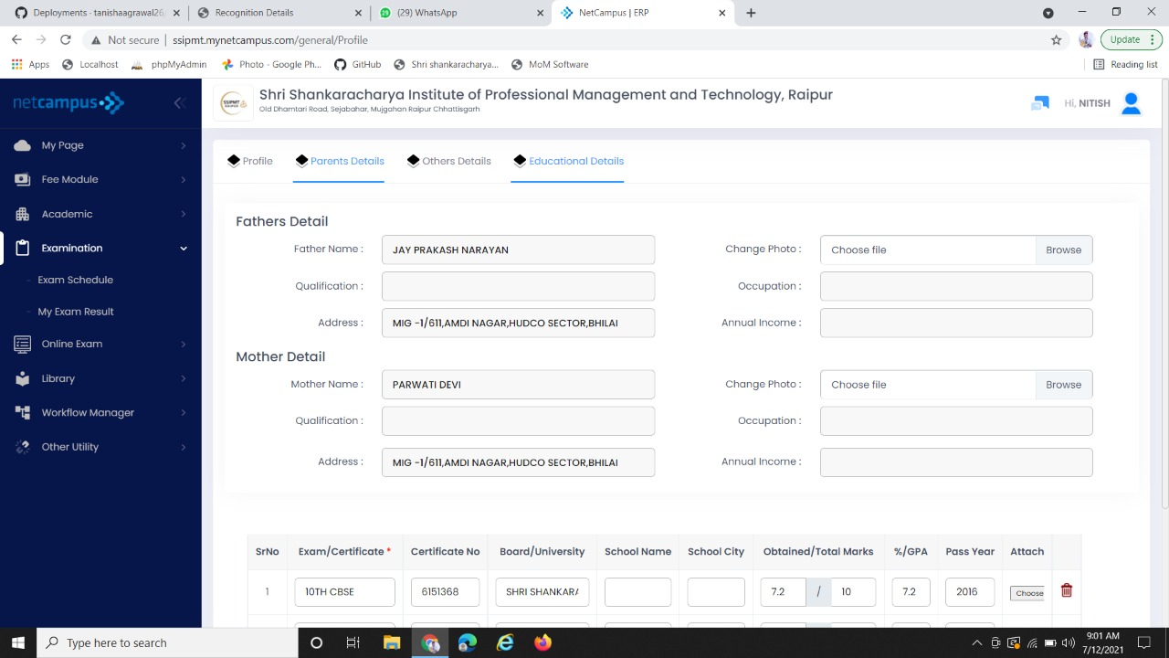

On clicking these modules you can edit your details